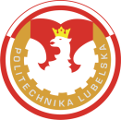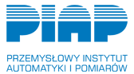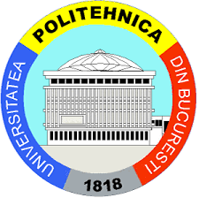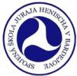

INTERNATIONAL SEMINAR
ON SCIENCE, TECHNOLOGY AND EDUCATION

“Robotics in practice and education”
30th – 31st October, 2017
Lublin, POLAND

The objective of the conference is to provide an international forum for the presentation and exchange of latest research findings and practical experience in the following areas:
1. design and automation of production processes,
2. robotics,
3. design and use of robots,
5. Robotics in education and didactics
Organizers of the seminar:
- Institute of Technological Systems of Information, Lublin University of Technology
- Department of Robotics, Technical University of Kosice
- Industrial Research Institute for Automation and Measurements, PIAP Warsaw
- University Politehnica of Bucharest, Faculty of Machines and Manufacturing Systems
- Spojena Skola Juraja Henischa in Bardejov
- Klaster AT+R, Kosice
Paper Submission
The papers must be submitted according to the submission guidelines given on the conference website. To be accepted for publication, the papers must pass the review process. The accepted papers will be published in Journal of Technology and Exploitation in Mechanical Engineering (http://www.jteme.pl/).
- The papers must be prepared using the template that can be downloaded here
- The number of pages allowed per paper is between 6 and 8 pages.
- Papers can only be submitted to one conference and must describe current original research of international interest.
- Papers need to be related to the main topic of the conference.
Article template and submission form you can download here
Papers and submission form please send to: j.zubrzycki@pollub.pl
Important Dates
25th October 2017 – paper submitting

Scientific Committee
- Adrian Olaru, Romania
- Antoni Świć, Poland
- Jarosław Zubrzycki, Poland
- Marek Vagas, Slovakia
- Marian M. Janczarek Poland
- Mikuláš Hajduk, Slovakia
- Vladimir Balazs, Slovakia
- Wojciech Klimasara, Poland
- Zbigniew Piłat, Poland

Organizing Committee
President:
- Prof. Antoni Świć, D. Sc., Ph. D., Eng.
Deputies to the President:
- Prof. Mikuláš Hajduk, D.Sc., Ph.D., Eng.
- Prof. Adrian Olaru, D.Sc., Ph.D., Eng.
Secretary:
- Dariusz Wołos, PhD., Eng.
Committee members:
- Jarosław Zubrzycki, PhD., Eng.
- Marek Vagas, PhD., Eng.
- Daniel Gąska, M.Sc., Eng.
- Łukasz Sobaszek, M.Sc., Eng.
- Łukasz Wojciechowski, M.Sc., Eng.
- Kamil Jonak, M.Sc., Eng.
- Róbert Jenčík M.Sc., Eng.
- Peter Dulenčin M.Sc., Eng.

